**Prasanna Dhungana**

**21053439**

**CSE**

**LAB ASSIGNMENT 2**

Q1. 1. Write a C Program to display “KIMS” using the character ‘#’.

***Program:-***

#include<stdio.h>

int main(){

printf("\n\n");

printf("\t # ## ######## ## ## ####### \n");

printf("\t # ## # # # # # ## \n");

printf("\t ### # # # # # # \n");

printf("\t ## # # # # ###### \n");

printf("\t ### # # # ## \n");

printf("\t # ## # # # # \n");

printf("\t # ## ######### # # ###### \n");

printf("\n\n");

return 0;

}

***Output:-***

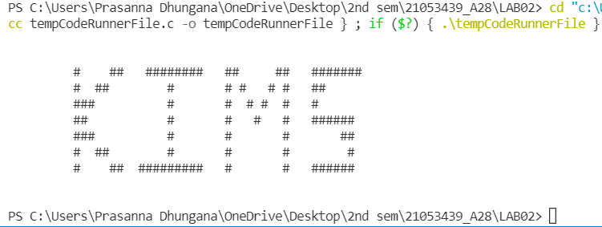

**2. Write a C program to display the following message by using multiple**

**printf() statement.**

**If The End Is Good,**

**Then It Is Good,**

**Whatever Be The Means**

***Program:-***

#include <stdio.h>

int main() {

printf("\n\n");

printf("\tIf The End Is Good,\n");

printf("\tThen It Is Good,\n");

printf("\tWhatever Be The Means\n");

printf("\n\n");

return 0;

}

**Output:-**

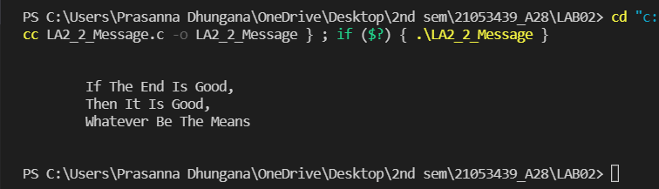

**3. Write a C program to display the same message mentioned above by**

**using a single printf() statement.**

***Program:-***

#include <stdio.h>

int main() {

printf("\n\n");

printf("\tIf The End Is Good,\n\tThen It Is Good,\n \tWhatever Be The Means\n");

printf("\n\n");

return 0;

}

***Output:-***

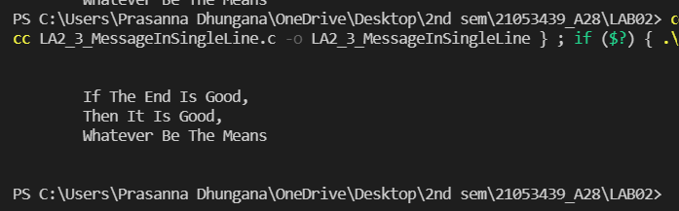

**4. Write a C program to compute the difference, product, quotient and**

**remainder for a pair of given integers and display the results.**

***Program:-***

#include<stdio.h>

int main(){

int numa3439, numb3439, diff3439, prod3439, quo3439, rem3439 ;

printf("\n\n");

printf("Enter any Two Numbers :\n");

scanf("%d %d",&numa3439, &numb3439);

diff3439 = numa3439-numb3439;

printf("The difference between two numbers is = %d\n",diff3439);

prod3439 = numa3439 * numb3439;

printf("The multiplication of two numbers is = %d\n",prod3439);

quo3439 = numa3439 / numb3439;

printf("The quotient is = %d\n",quo3439);

rem3439 = numa3439 % numb3439;

printf("The remainder is = %d\n",rem3439);

return 0;

}

***Output:-***

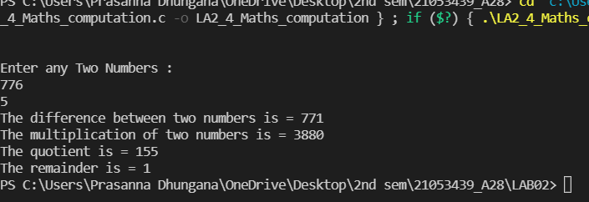

**5. Write a C program to find Fahrenheit for a given Celsius temperature.**

***Program:-***

#include<stdio.h>

int main(){

float c3439, f3439;

printf("\n\n Enter the temperature in Celsius :");

scanf("%f",&c3439 );

f3439=(c3439*1.8)+32;

printf("The temperature in Fahrenheit scale is %.1f\n\n", f3439);

}

***Output:-***

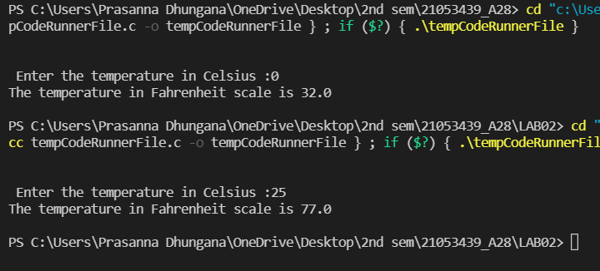

**6. Write a C program to calculate the surface area and the volume of a**

**sphere.**

***Program:-***

#include<stdio.h>

const float pi=3.14;

int main(){

float r3439 , sa3439, v3439;

printf("\nEnter the radius of the sphere :");

scanf("%f",&r3439);

sa3439 = 4 * pi * r3439 * r3439 ;

printf("The surface area of the sphere with radius %.1f is %.2f", r3439, sa3439 );

v3439 = (4/3) * pi * r3439 * r3439 * r3439;

printf("\nThe volume of the sphere with radius %.1f is %.2f\n\n", r3439, v3439 );

return 0;

}

***Output:-***

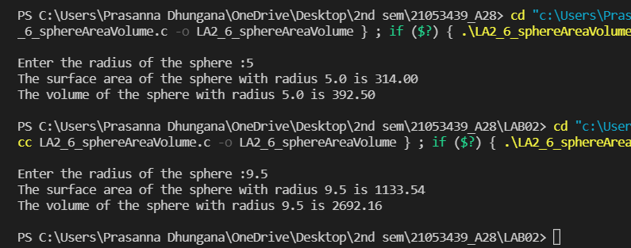

**7. Write a C program to calculate the area of a triangle whose lengths of**

**three sides are given.**

***Program:-***

#include<stdio.h>

#include<math.h>

int main(){

int a3439, b3439, c3439 ;

float ar3439 , s3439;

printf("\n\nEnter the size of three sides of the triangle:");

scanf("%d %d %d", &a3439, &b3439, &c3439);

s3439 = (float)((a3439+b3439+c3439)/2);

ar3439 = sqrt(s3439 * (s3439-a3439) * (s3439-b3439) * (s3439-c3439));

printf("The area of the triangle is %f\n\n",ar3439);

return 0;

}

***Output:-***

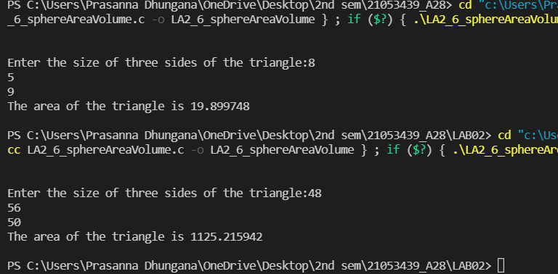

**8. Write a C program to swap two integer numbers without using a third variable.**

***Program:-***

#include<stdio.h>

int main(){

int x3439, y3439;

printf("Enter two numbers:\n");

scanf("%d %d",&x3439, &y3439);

x3439 = x3439 + y3439;

y3439 = x3439 - y3439;

x3439 = x3439 - y3439;

printf("The variable are swapped as %d and %d .\n\n", x3439, y3439);

return 0;

}

***Output:-***

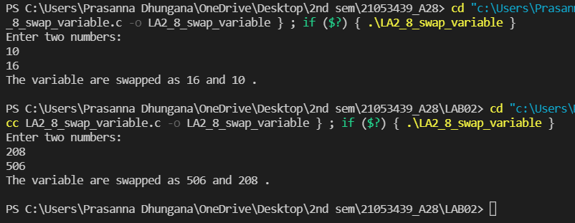

**9. Write a C program to print your BIO-DATA (Name, Roll No, Branch, JEE**

**Rank, Gender, Phone no., Address, etc.) using printf() statement.**

***Program:-***

#include<Stdio.h>

int main(){

printf("\n\nName : Prasanna Dhungana \n");

printf("Roll No: 21053439\n");

printf("JEE Rank : N/A \n");

printf("Gender : Male\n");

printf("Phone No: +9779863347999\n");

printf("Address : Tansen-6, Palpa, Lumbini, Nepal\n\n");

return 0;

}

***Output:-***

